# 1. Start SQL Profiler by one of the following ways:

- Click **Start\All Programs\Microsoft SQL Server XXX\ Performance Tools** and choose **SQL Server Profiler**

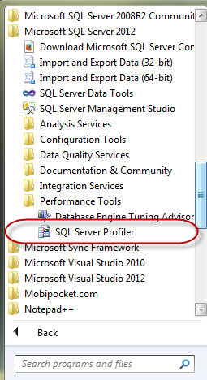

- From **SSMS** choose **Tools \ SQL Server Profiler**

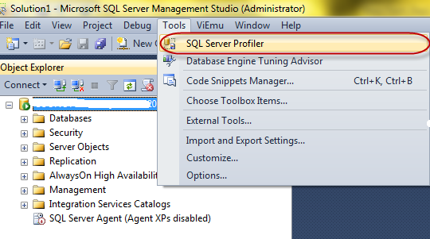

**2. Events Selection**

- In the **Event Selection** tabl of **Trace Properties** dialog, choose Events that will be captured as Stored Procedures, TSQL...

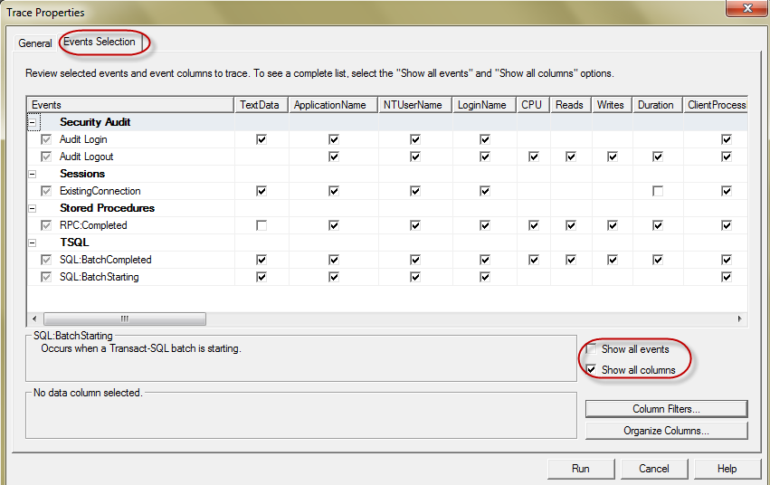

- Specific Database which Profiler will trace. Click **Column Filters...** button, select **DatabaseName** and enter *AdventureWorks* into **Like**

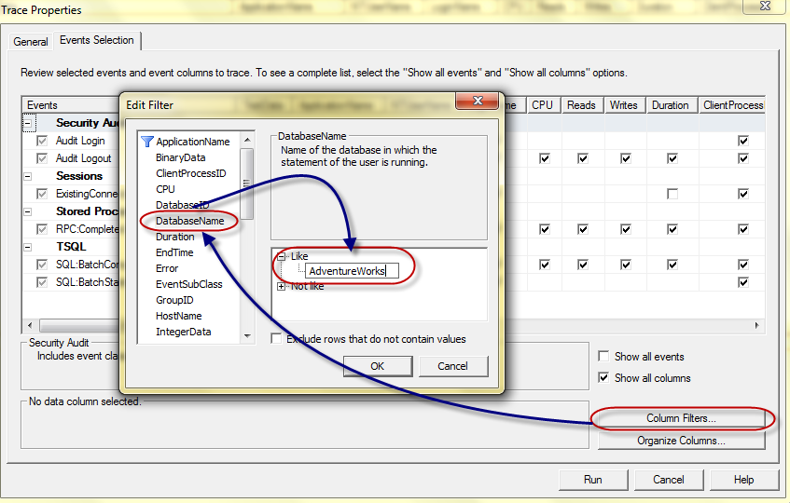

# 3. Capturing T-SQL events

- In SSMS types:

SELECT * FROM [HumanResources].[Employee]

and run (F5) under AdventureWorks database

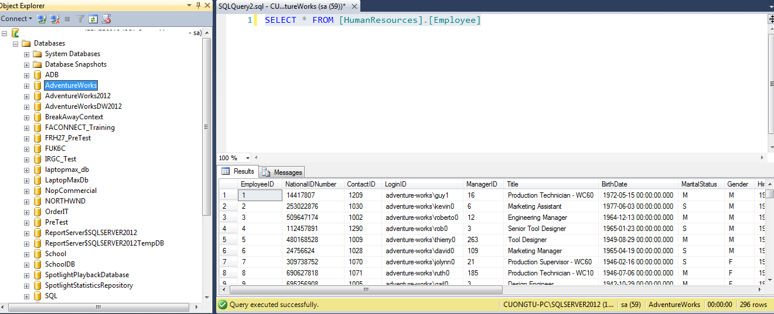

- Go back SQL Server Profiler, it shows:

* T-SQL statement in the **TextData** column
* The time that query takes in **Duration** column (173 ms)
* I/O information in **Reads, Writes** column

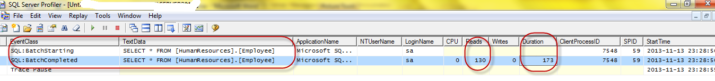

# 4. Capturing Stored Proc events

Copy and **Execute** below statement

USE AventureWorks

GO

EXEC dbo.uspGetManagerEmployees 16

